ASSESSMENT 2: Professional Experience Reflection
TANIA LOUISE WORRALL 18528730

1. Numeracy introduction reflection

The focus of my numeracy lesson “Our Coins” was to recognise, describe and sort current Australian coins.
I placed large magnetic cardboard coins, 5 cents through to $2, on the board and my introduction began by asking the Prep students: “Can you tell me what’s on the board?” Questions followed quickly and easily from their many responses. “How would you describe them?” “What makes them special” and “Different from one another”?
That took me on to individual discussions about the Australian animal featured on each coin, if they had ever seen a lyrebird, etc, and then asking students to guess what was on the back of the coins (the Queen and the date) and why they were there.
Reflecting on my audio recording, I think my voice was loud and clear but my presentation began a little rushed. Once I started to relax and listen, I felt more comfortable.
It was a fine balance of asking questions and listening to answers, and not letting those develop into never-ending stories of “When I first saw a kangaroo …”
The challenge was to know when to move on and when to continue a valuable line of discussion.
Before I began, I knew the students had used Australian money in class but had not discussed them in detail in a specific numeracy lesson. As we were close to the end of the year, students were ready to work towards the AUSvels requirements of (ACMNA017) Recognise, describe and order Australian coins according to their value, and elaborations of understanding that the value of Australian coins is not related to size and describing the features of coins that make it possible to identify them.
I realised that, as part of my focus, a visual and tactile experience would be the most appropriate method. Also, I knew that without an interactive whiteboard and only a projector and three iPads to work with, that hard copies would be the way to go. And that with a maximum of 20 students sitting in front of the class with the students on the mat, sharing pictures, looking at books, etc, would be fine.
I adapted the content as I went along. I think my explanations were thorough because I researched the topic and had all my materials sorted and kept my notes at hand, as my mentor teacher suggested. I had read and written down extra information I thought was interesting and thought-provoking to share and that came in handy as the introduction moved along fast. And the children were engaged. For example, I printed out a picture of Don Bradman, showed it to the class and asked if anyone knew who he was. Some knew he was famous, some knew he played cricket, and all were excited when I told them he would soon be on the 20 cent coin, as it was time for the platypus to leave after nearly 50 years.
But a double lesson does have its challenges. In the future, I think I would structure the lesson differently. A shorter introduction, 10 to 15 minutes instead of 22 minutes, would work better to engage the students, keep the information fresh in their minds before embarking on some group “shopping” with coins. Then perhaps I could call them back to the mat for another explanation before working on an activity sheet and lastly a group reflection.
I would also have liked more strategies up my sleeve for class management. Should I continue to chastise those few who are talking in the back or ignore them? And how do I bring reluctant participants into the conversation without putting them on the spot with a question?
Lastly, when instructing what would follow the introduction, what we do next, the transition was noisy and the group activity was not explained well enough. I need to remember to model explicitly. How else do young students know what is expected of them? In particular I would break down the group activity into small learnable segments, think aloud as I show each step, and let students ask questions for clarification.

2. Running record analysis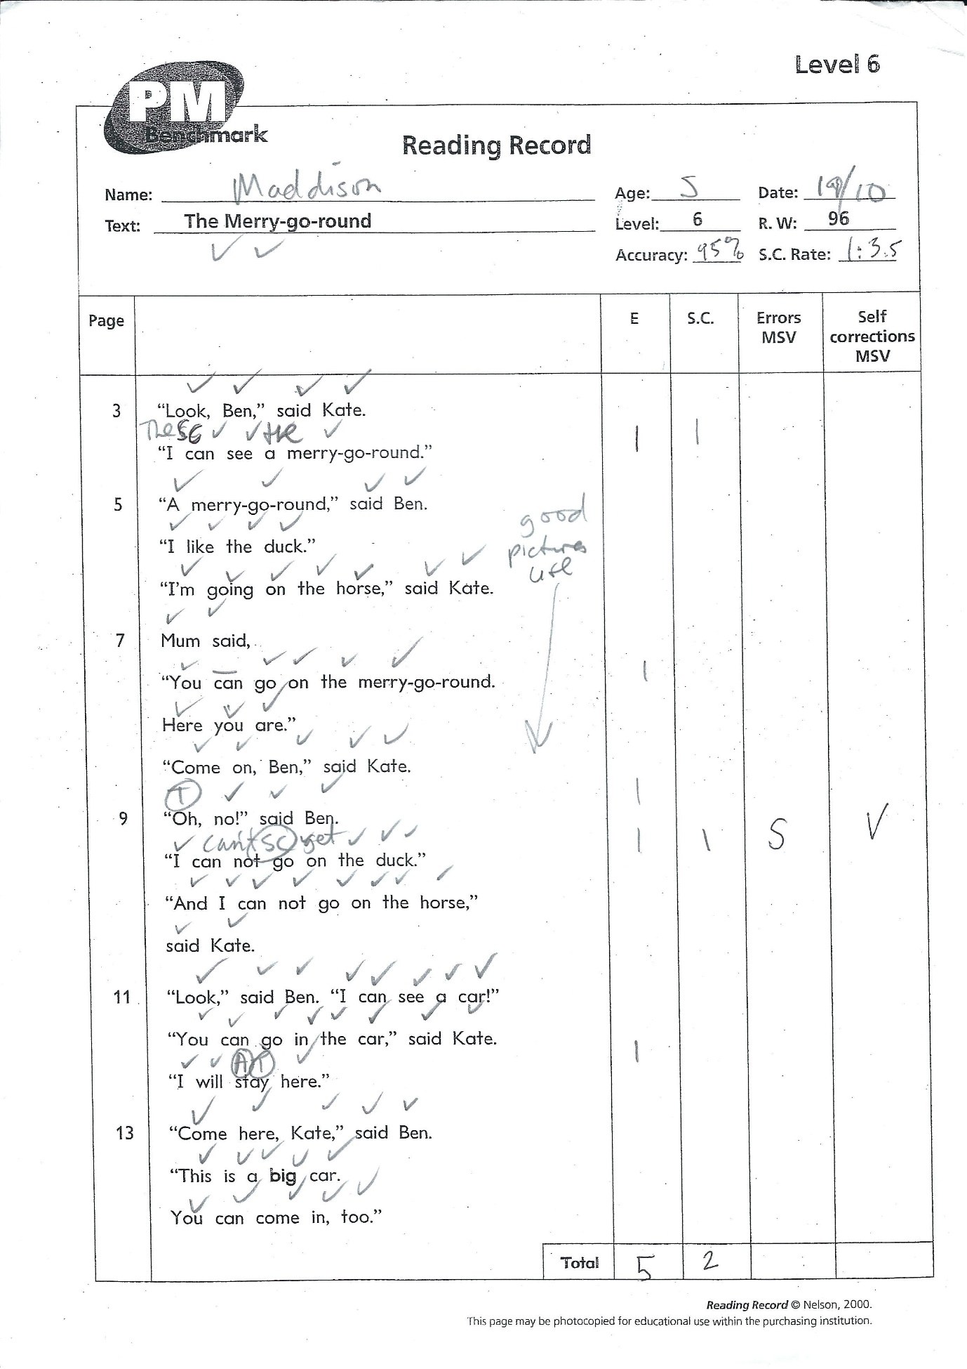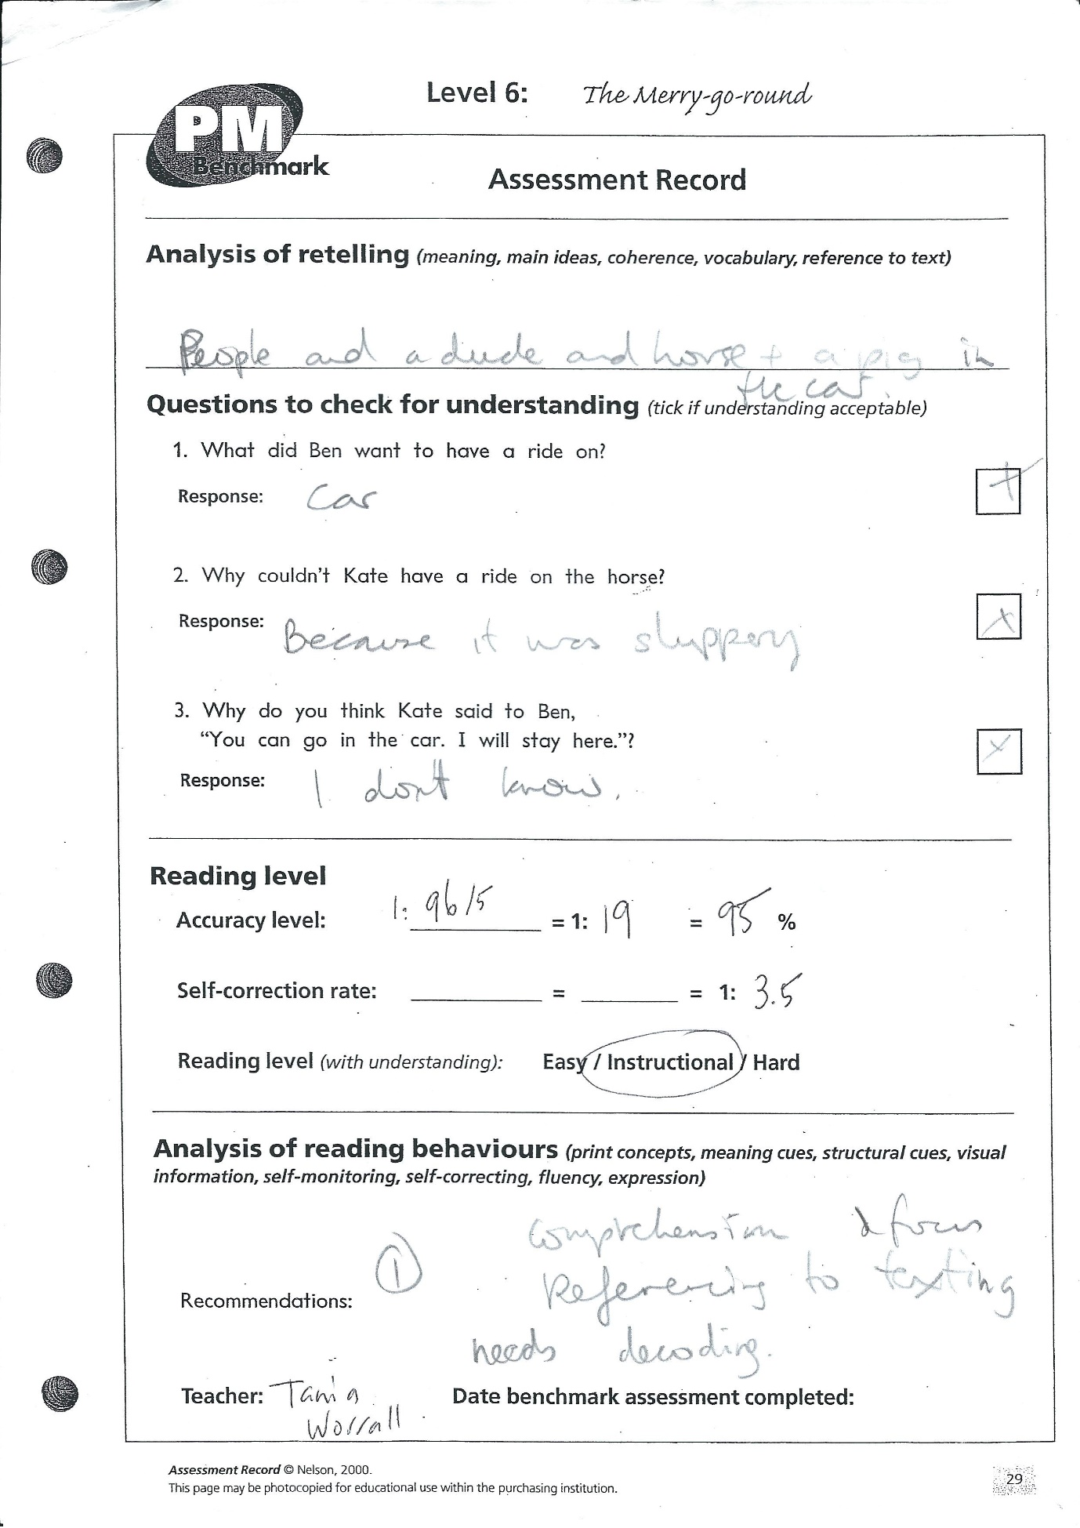

Maddison read her Level 6 book correctly, with only five errors. She recognised most of the Special Words (Fitzroy Method) without sounding them out and used pictures along the way to self-correct. However, her re-telling of the story was poor and her poor expression was the first indication of her lack of understanding. Further analysis consolidated this.
When questioned about the book, Maddison’s answers showed a lack of comprehension, including story line, characters and any referencing to text. She struggled to answer and gave incorrect information to all three questions.
So, while the reading level appeared easy, due to the accuracy rate of 95%, it was correct to recommend an instructional reading level. My mentor teacher agreed.
Many of Maddison’s classmates who read to me also struggled with comprehension. But this is not unusual.
Often as beginning readers, children are so aware of reading accurately that they forget to take time and think about what they are reading.
To be able to accurately understand written material, children need to be able to decode what they read, make connections between what they read and what they already know and think deeply about what they have read.
So to develop Maddison’s comprehension skills, I would concentrate on strategies that help her to recall what is happening in the story, understand story structure and “become more accurate in monitoring … understanding”. In The CAFÉ Book, Gail Bensley and Joan Moser’s strategy “Retell The Story” involves explicitly teaching what is important without telling too much, and understanding the key points in sequence. Not only would this benefit Maddison’s reading but her story writing too.
Other strategies include modelling in readalouds, using language like:
- “Who are the main characters?”
- “What problem did the main characters have?”
- “How was the problem solved?”
- “How did the story end?”
- “What happened first, second and last?”
With Maddison specifically, I need to remind her to think about what she is reading and to stop and “back-up” and “re-read” if she can’t remember.
Also important I think for Maddison, is engagement. Keeping it interesting and relevant is important for all young readers. Checking the content of the book, and then perhaps choosing something different (more pictures, different font, interesting story line) might prove beneficial. Different book genres are worth exploring too as children progress through the early readers, like sports books, science fiction in general and fairy tales.
By listening to good models of fluent reading, students learn how a reader's voice can help written text make sense. Reading aloud daily to students makes a difference; I’ve seen it in my classroom. By reading effortlessly and with expression my mentor teacher modelled how a fluent reader sounds during reading.
After modelling how to read the text, she has the students reread it. By doing this, the students are engaging in repeated reading. She also recommends other adults read aloud to students, and encourages parents to read aloud to their children at home. Perhaps this is where Maddison also needs further assistance and encouragement. The more models of fluent reading the children hear, the better.
Reciprocal reading, scaled to a Foundation level, could also be beneficial for Maddison. I think her confidence and contribution would improve in a guided group setting where she can see her peers predict, summarise, question and clarify after watching the teacher model the process.
Reciprocal teaching develops sound literacy skills “while at the same time developing students’ ability to think critically.” (Biggs & Moore, 1993). There is strong evidence that RT is an effective teaching method that produces notable improvements in reading comprehension (Hattie, 2009).
Moreover, “most importantly, the RT process becomes a means of making literacy skills a major focus of education.”
The average worker of the future will need the ability to gather, organise and interpret information of all types (Rowe, 2005). In order to prepare students for their future roles in life, teachers need to ensure that cognitive and metacognitive reading skills are explicitly taught to their students.

3a. Numeracy lesson with ICT focus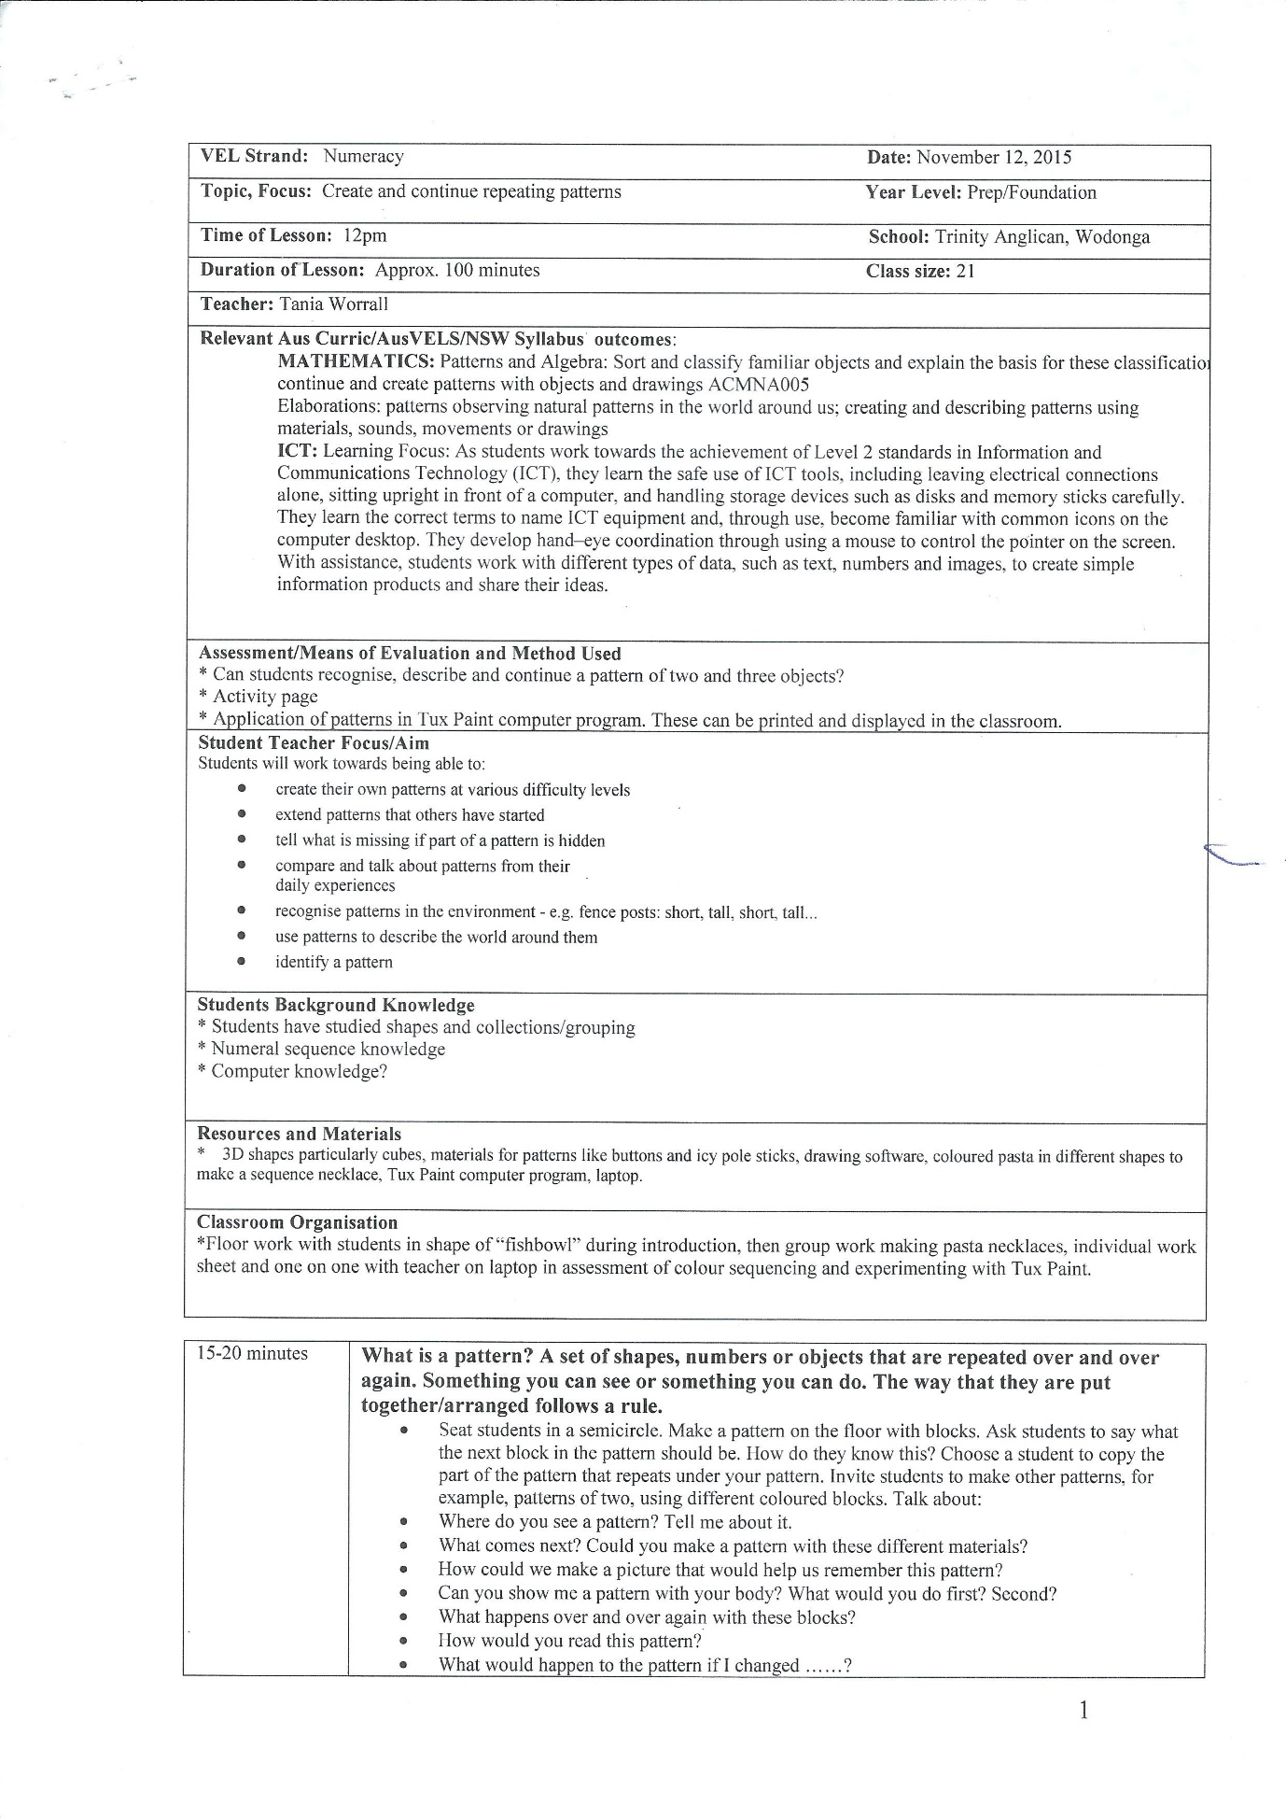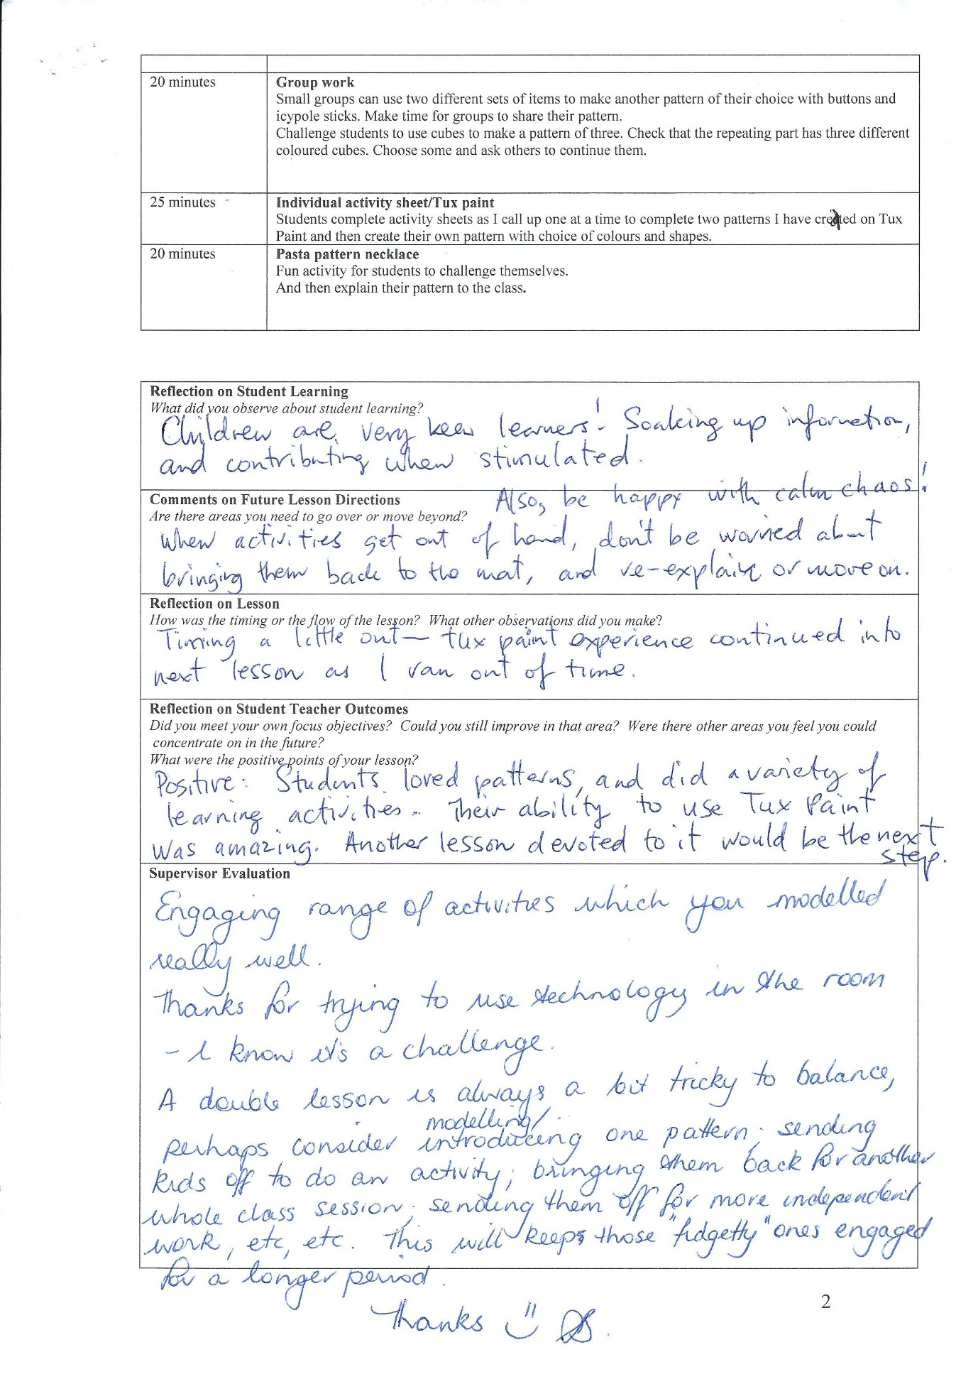

There was considerable planning involved prior to my numeracy lesson on patterns, and the introduction to the drawing program Tux Paint, which is suitable for children ages 3 to 12.
At my school ICT resources were limited: a lab of 20 computers was available but was only used twice during my placement, for students to play Mathletics. Computers were logged on prior to the Preps arrival, and computer knowledge was varied.
In the classroom there were three iPads, a projector but no interactive whiteboard. So I decided to use my laptop, which has Tux Paint already downloaded, as an individual assessment on patterns towards the end of the double lesson. That way, as the class worked on pasta pattern necklaces, I would have one-on-one time with each student to remind them how to use a mouse, how to hover and scroll, select and Undo, and then to complete a pattern I had begun … and have some fun creating their own at the end!
I was instantly surprised and pleased how the students adapted to their first use of this program (all but one told me they were unfamiliar with it). They were excited to try something different and nearly all students needed only one explanation of the task at hand. In fact, most found the use of the scroll bar on the laptop more convenient and went with that instead of using the mouse. Some consolidation was needed in reminding students about the importance of repetition in patterns before they were able to go ahead with the task: completing one simple colour block pattern and one more challenging pattern, with repeats of one and two and a mix of colours.
Initially, I had my laptop set up at the front of the room, at the teacher’s desk, but it was too noisy for one-of-one instruction so I moved to the back of the class in the “reading corner” which was much better. I could still keep an eye on the class while attending to my individual assessment.
My biggest downfall was with the structure of the numeracy block: in the end we ran out of time. Most would have loved longer on the computer, but considering there were 18 students, I could only give each five minutes each, and still then the bell went for recess with four students still to go. Luckily I was able to finish with these students in fifth period after recess due to a flexible timetable and the help of my mentor teacher.
However, if I was being realistic and was in that classroom setting again, I don’t think I could have done it differently. I think as an introduction to Tux Paint it was fine. The numeracy block was long, a double period, and we looked at many ways of recognising and making patterns, in nature and with numbers, and I think at this age, and with their level of ICT knowledge, to finish of a lesson like that was relaxing and interesting.
It also lends itself to a follow up lesson with Tux Paint in the computer lab at a later date, where I would roam the room as students create their own patterns, print them out and then use them later for a craft/art activity.
With regards to the learning outcome, and in line with the AusVELS I included in my plan and the Australian curriculum, I think this lesson was successful.
Some of the ICT general capabilities required of the Preps were covered with the use of Tux Paint. These included:

Creating with ICT Generate solutions to challenges and learning area tasks: Use ICT as a creative tool to generate simple solutions
Managing and operating ICT: Select and use hardware and software; identify and safely operate ICT systems to complete relevant simple specified tasks and seek help when encountering a problem
Manage digital data: Save and retrieve digital data with support
The Australian Curriculum recognises it is vital that children are able to make sense of the world they live in, that they feel at ease with the technology that surrounds them and that they develop the necessary knowledge, skills, understanding and attitudes that will enable them all to utilise technologies to their full potential.
They will then grow up to be “digitally literate” confident citizens who are able to live, learn and take an active part in society and who are equipped for the new jobs and challenges that the future may bring.
I loved researching multiliteracy and numeracy earlier in the year. It makes sense to introduce computers into schools early to “prepare children for their future lives in the Knowledge Society.”
“This is a society where knowledge-workers will increasingly be required to control their own learning, and critically evaluate and manipulate information in the development of new knowledge products,” writes Neil Selwyn, of Monash University.
It’s all about teaching a necessary life-skill. Problem solving, communication, collaboration, analysing and critical thinking in general, when taught as a processes, a fluency, value the individual over content. “When content starts to fade the process remains and students will have the skills necessary for their life beyond school,” writes Lee Crockett.
And I can see as a preservice teacher that supporting these new ways of understanding knowledge requires significant effort by educators to build new information skills.
In many ways, our world today is about connecting the digital dots. As Barbara R. Jones-Kavalier writes, to successfully connect the dots at any level in cyberspace means we must be literate, both digitally and visually.
Teaching “headware” (not hardware) skills makes sense. Every digital device should be considered for its academic potential but the goal is not to teach technology but to teach thinking skills and challenge students to communicate their understanding of the learning outcomes in whatever way that speaks to them.
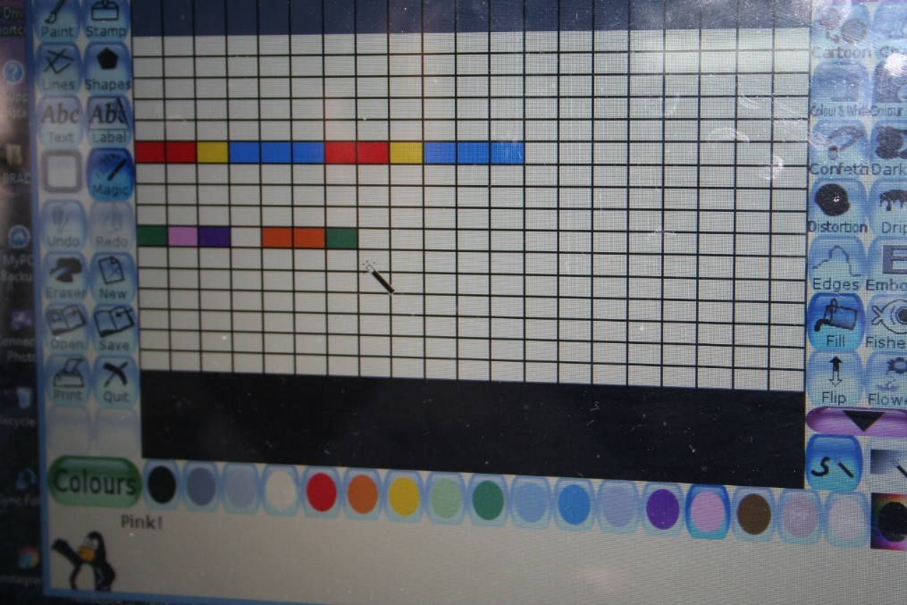
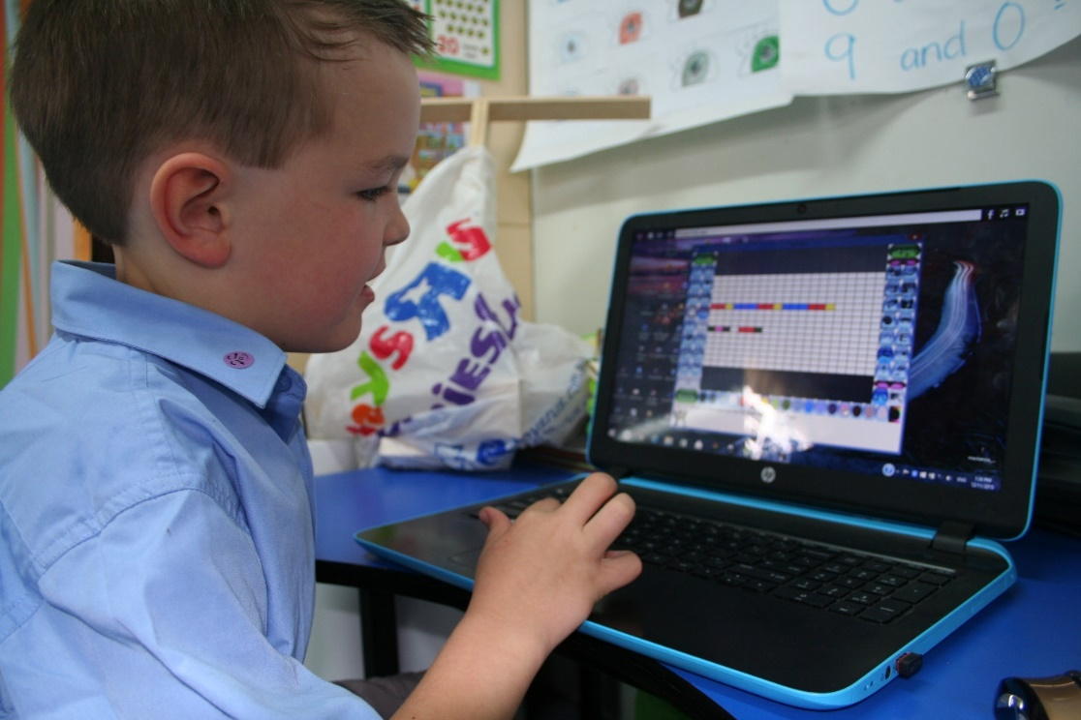
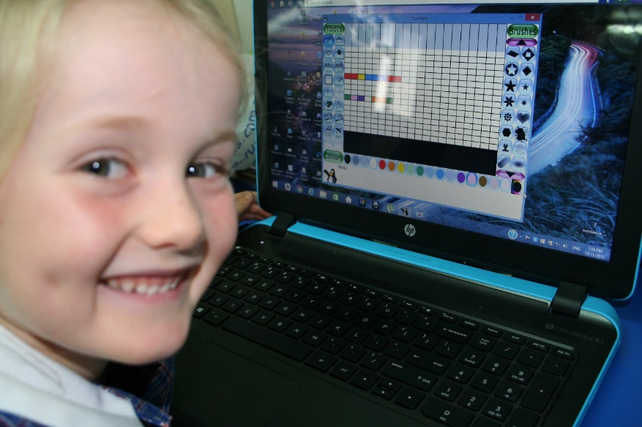
REFERENCES

Australian Government, Department of Education. (2015). Retrieved from http://www.australiancurriculum.edu.au/generalcapabilities/information-and-communication-technology-capability/continuum#layout=row
Bensley, G. & Moser, J. (2009). The CAFE Book: Engaging all Students in Daily Literacy Assessment and Instruction. Stenhouse Publishers: Portland, Maine
Biggs, J.B., & Moore, P.J. (1993). The process of learning (3rd ed). Sydney: Prentice Hall of Australia Pty Ltd.
Cooper, T. & Grieve, C. (2008). The effectiveness of the methods of reciprocal teaching as applied within the NSW primary subject Human Society and its Environment. Retrieved from http://research.avondale.edu.au/cgi/viewcontent.cgi?article=1127&context=teach

Crockett, L. (2011). Literacy Is NOT Enough: 21st Century Fluencies for the Digital Age. California: Corwin Publishers.

Hattie, J. (2009). Visible learning: A synthesis of over 800 metaanalyses relating to achievement. London: Routledge

(2006). Connecting the Digital Dots: Literacy of the 21st Century. Retrieved from http://er.educause.edu/articles/2006/1/connecting-the-digital-dots-literacy-of-the-21st-century

Rowe, K. (2005). Teaching reading: The report and recommendations from the Committee for the National Inquiry into the Teaching of Literacy. Australian Council for Educational Research. Retrieved http://www.acer.edu.au/enews/0512_NITL.html
Selwyn, N. (1999). Resisting the Technological Imperative: Issues in Researching the ‘Effectiveness’ of Technology in Education. Retrieved from the online journal Compute-Ed, http://pandora.nla.gov.au/nph-arch/2000/Z2000- Jun-5/http://computed.coe.wayne.edu/Vol5/Selvynsiuh

